**Low Level Design**

|  |  |
| --- | --- |
| **Project Code** | Group 3 |
| **Project Name** | University Admission System |

|  |  |  |
| --- | --- | --- |
| **Prepared / Modified by** | **Role** | **Date of preparation/ Modification** |
| Nupur, Gangotry | Senior Analyst | 04-08-2018 |
| **Reviewed by** | **Role** | **Date of review** |
| Tanmaya Acharya | Mentor |  |
|  |  |
|  |  |
| **Approved by** | **Role** | **Date of Approval** |
| Tanmaya Acharya | Mentor |  |
| **Circulation List** | [nupur.singh@capgemini.com](mailto:nupur.singh@capgemini.com)  [gangotry.vishwakarma@capgemini.com](mailto:gangotry.vishwakarma@capgemini.com)  [ankit.saha@capgemini.com](mailto:ankit.saha@capgemini.com)  [aditya.mundada@capgemini.com](mailto:aditya.mundada@capgemini.com)  [chhavi.b.gupta@capgemini.com](mailto:chhavi.b.gupta@capgemini.com)  [sri-kanth.juluru@capgemini.com](mailto:sri-kanth.juluru@capgemini.com) |  |
| **Version number of the work product** | Version 1.0 |  |

Table of Contents

1. Description of the unit …………………………………………………………3

2. References …………………………………………………………………….4

3. Dependencies / Assumptions ………………………………………………..5

4. Class Diagrams ……………………………………………………………….6-14

5. Sequence Diagrams …………………………………………………………15

6. Design Components ………………………………………………………….16-20

6.1 List of UI Components …………………………………………………16-19

6.2 List of Design Classes ……………………………………………………..20

7. Reusable Routines / Components ………………………………………….21

8. Messages ……………………………………………………………………..22

9. Configuration Files …………………………………………………………...23

10. Crud Matrix Table …………………………………………………………24

11. Data Mapping Table ……………………………………………………….25

12. Action Flow Matrix …………………………………………………………26

13. Stored Procedures …………………………………………………………27

14. Program Specification/ Pseudo Code ………………………………….28-29

REVISON HISTORY OF THE WORK PRODUCT ………………………..30

# Description Of The Unit

This project is aimed at developing University Admission System for seeking admission in the university. This is a web based application that can be accessed over the web. This system can be used for applying for the courses in the university. This is an integrated system that contains three user components, Admin component, Member of Admission Committee (MAC) component and Applicant.

In this LLD, we will be designing for the Add Program Module. The add program module allows the admin of the University Admission System to add new programs into the database. This module can be used only by the admin of the university management application.

On clicking the add program button under program tab in the admin home page, the admin is redirected to a add programs offered page. The admin has to enter all the details of the program like program name, program description, applicant’s eligibility, duration and degree certificate offered by university. If the entered program details are invalid, appropriate error messages are displayed. If the details entered are correct, they are inserted into the database on clicking the add button.

# References

| **Reference** | **Description** |
| --- | --- |
| Repository reference | https://github.com/adityamundada/University-Admission |
| Class Diagram | https://github.com/adityamundada/University-Admission/tree/master/PLP/Project%20Documents/Design%20Documents/HLD/ClassDiagram |
| URS | https://github.com/adityamundada/University-Admission/tree/master/PLP/Project%20Documents/Requirements/Case%20Study |
| UTP | https://github.com/adityamundada/University-Admission/tree/master/PLP/Testing/UTP |
| DB Design | https://github.com/adityamundada/University-Admission/tree/master/PLP/Project%20Documents/Design%20Documents/HLD/DB%20Design |

# Dependencies / Assumptions

**Dependencies:**

The admin should be logged in.

**Assumptions:**

The admin details are stored in the database.

# Class Diagrams

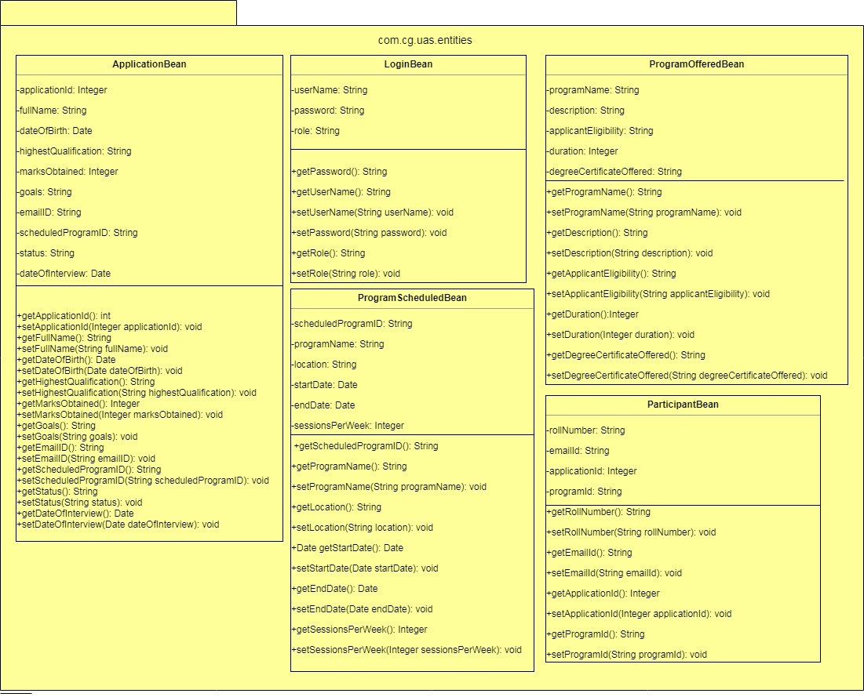

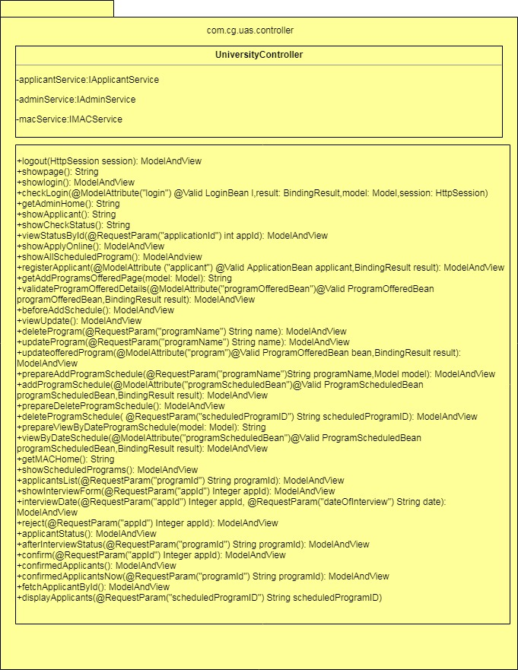

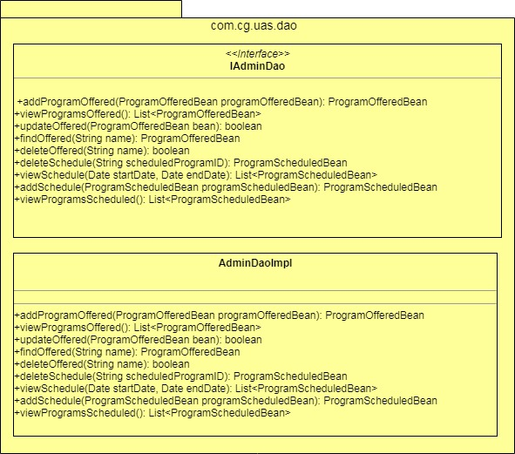

\\ntblrfs001\trng_blr$\BANGALORE FRESHERS\JEE 4July18 DTP BLR\Mini Project\GROUP 3\ClassDiagram\AdminService.png

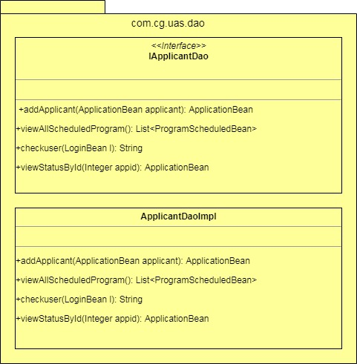

\\ntblrfs001\trng_blr$\BANGALORE FRESHERS\JEE 4July18 DTP BLR\Mini Project\GROUP 3\ClassDiagram\ApplicantService.png

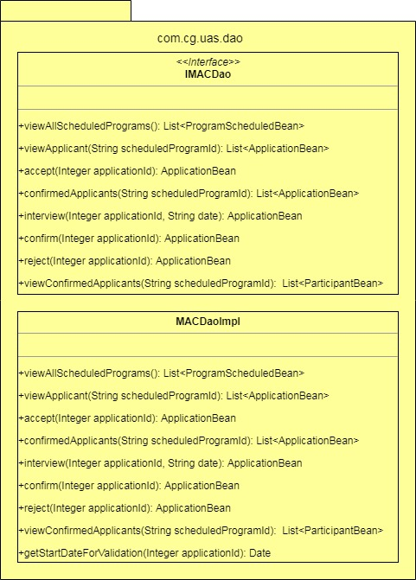

\\ntblrfs001\trng_blr$\BANGALORE FRESHERS\JEE 4July18 DTP BLR\Mini Project\GROUP 3\ClassDiagram\MacService.png

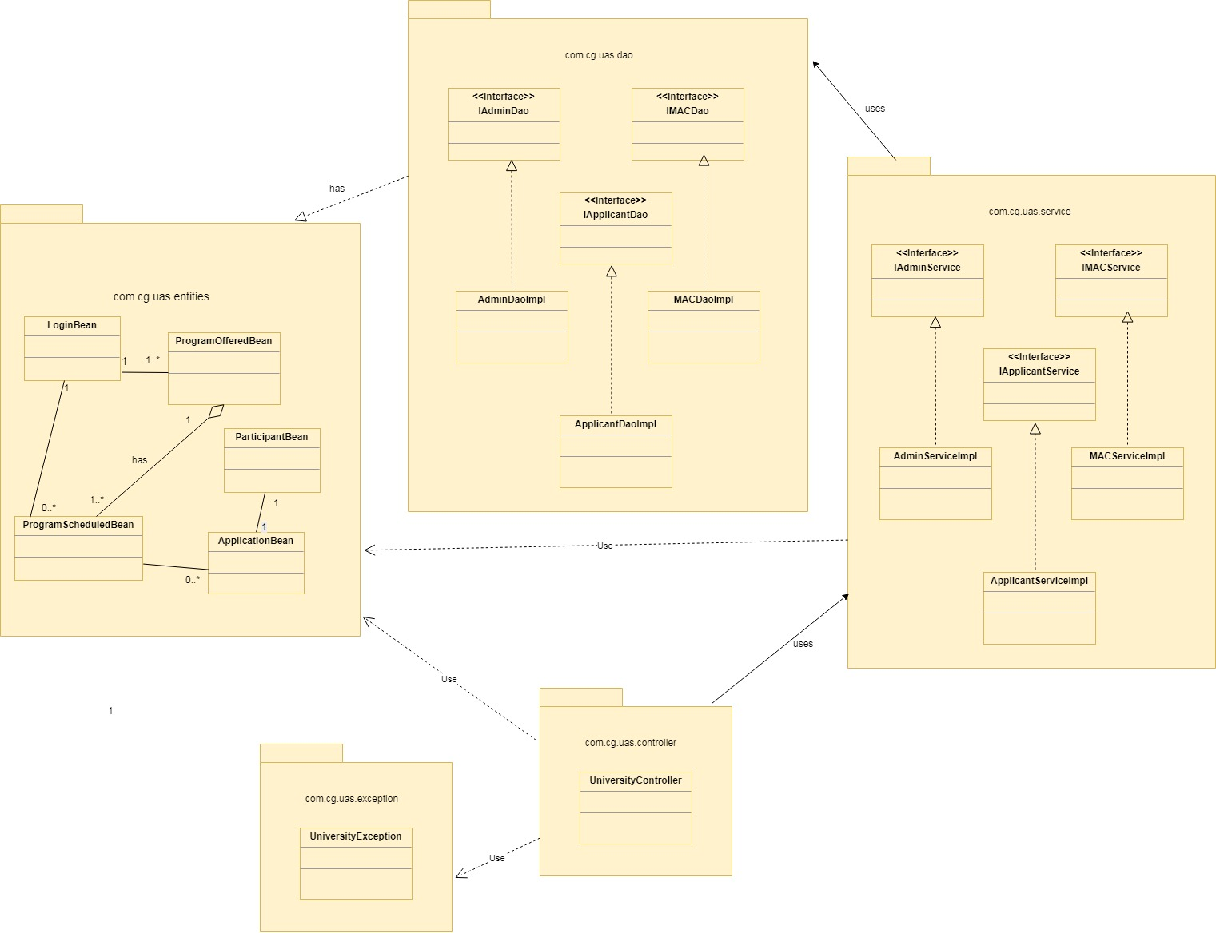

# Sequence Diagrams

**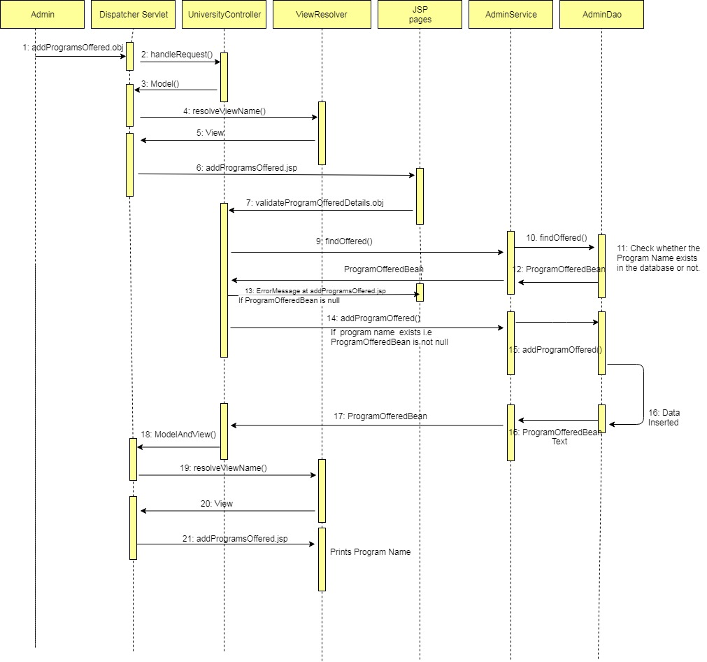**

# Design Components

## List Of UI Components

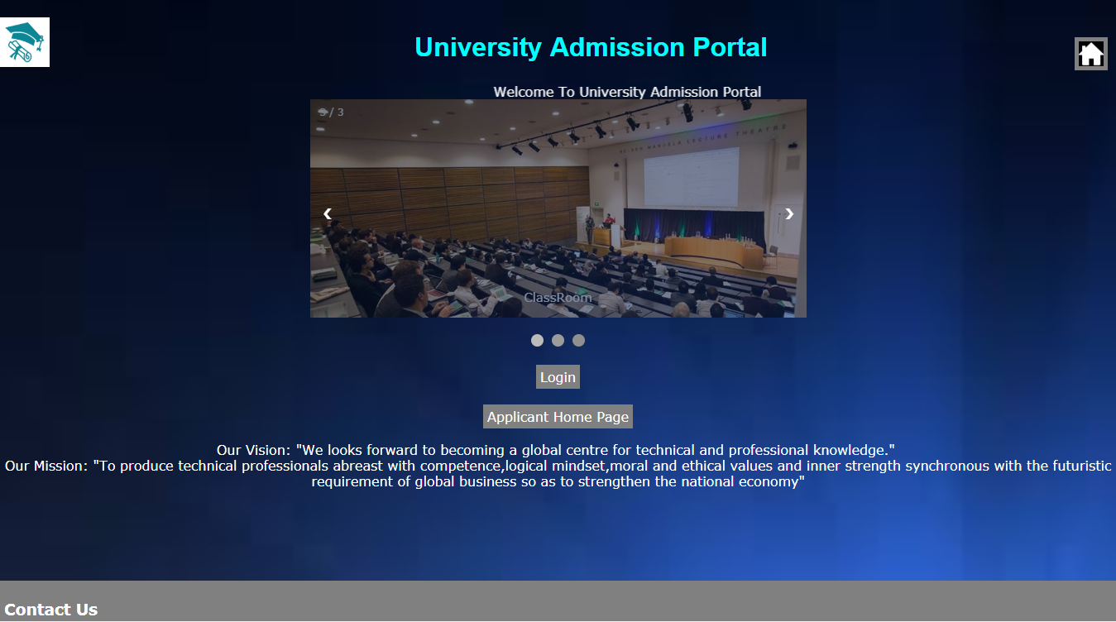

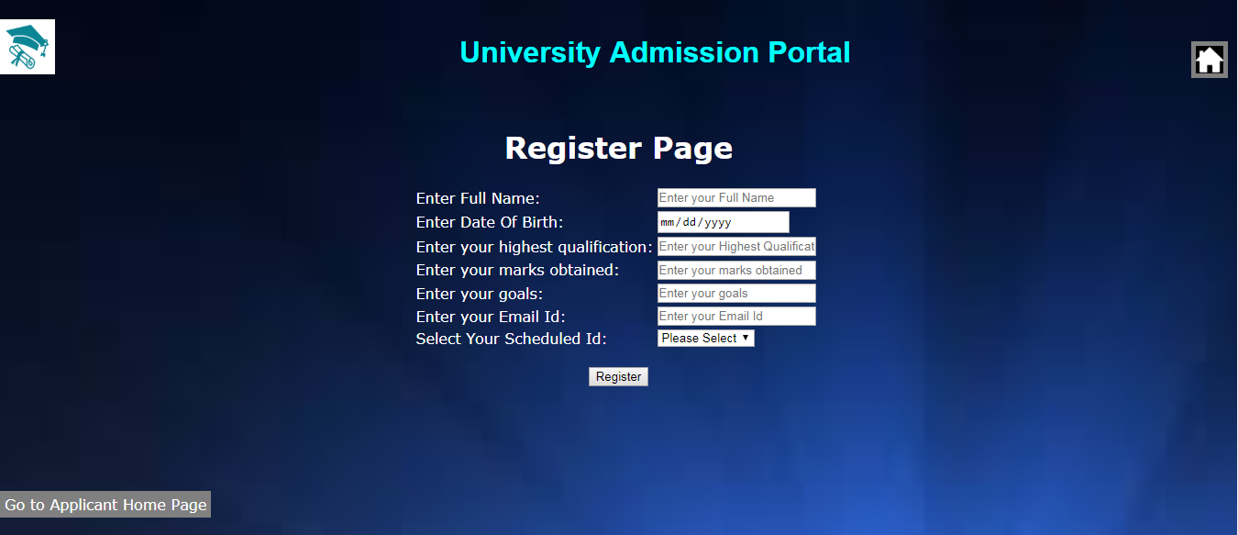

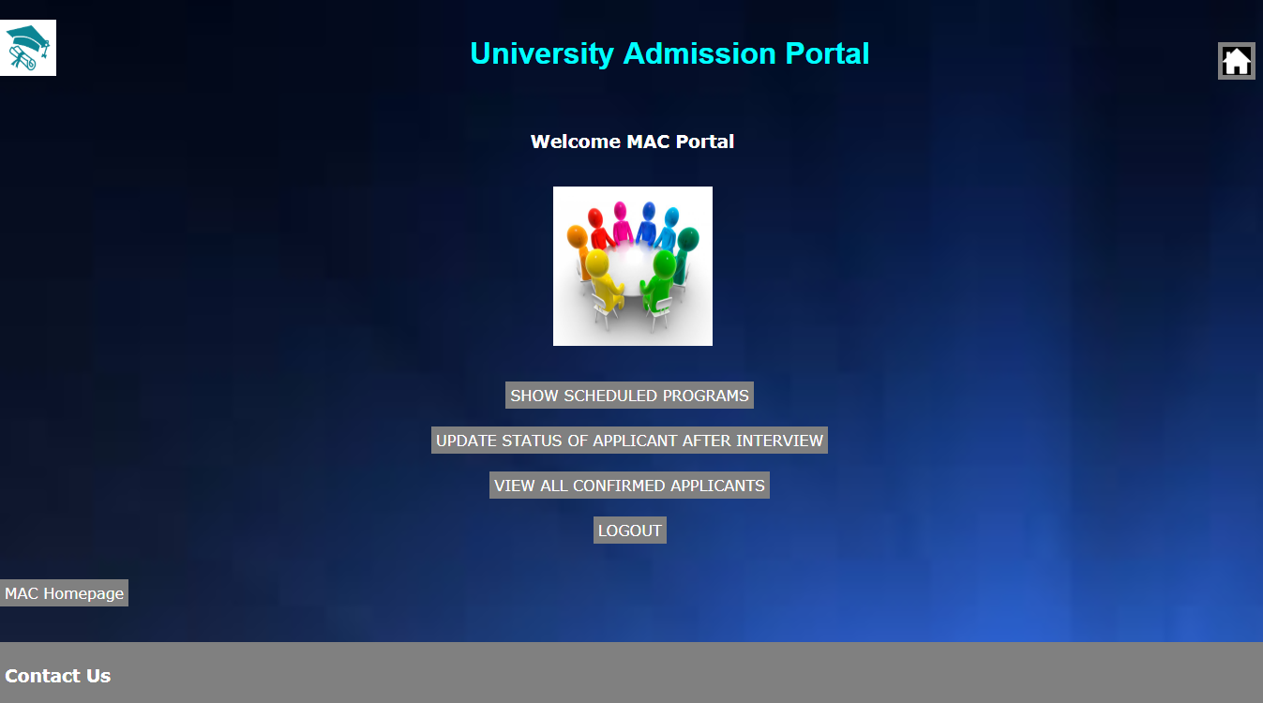

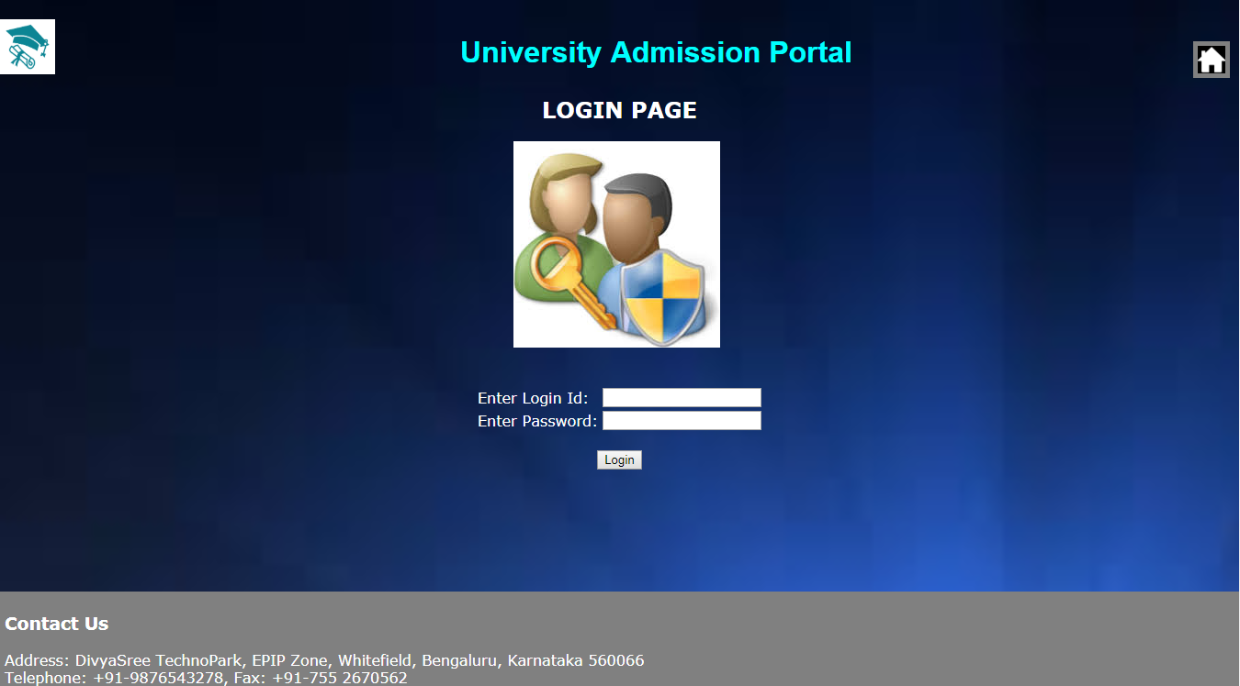

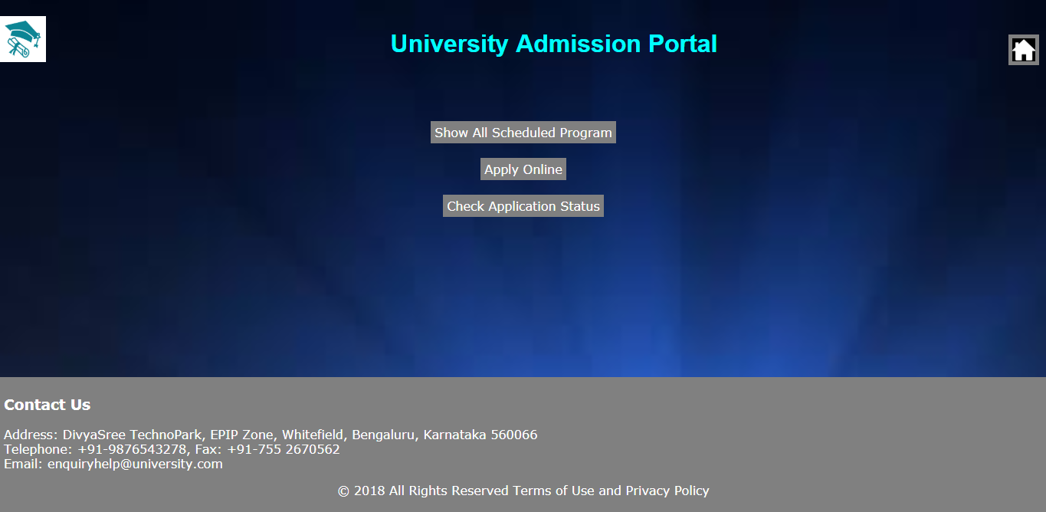

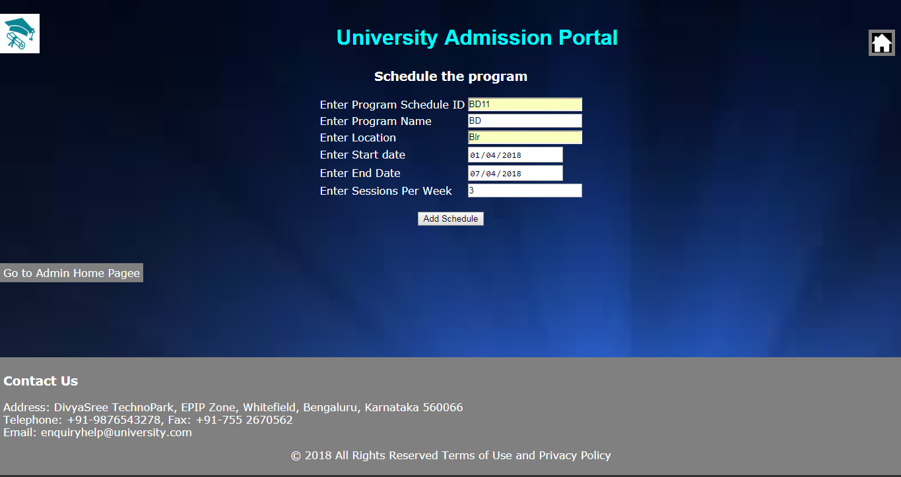

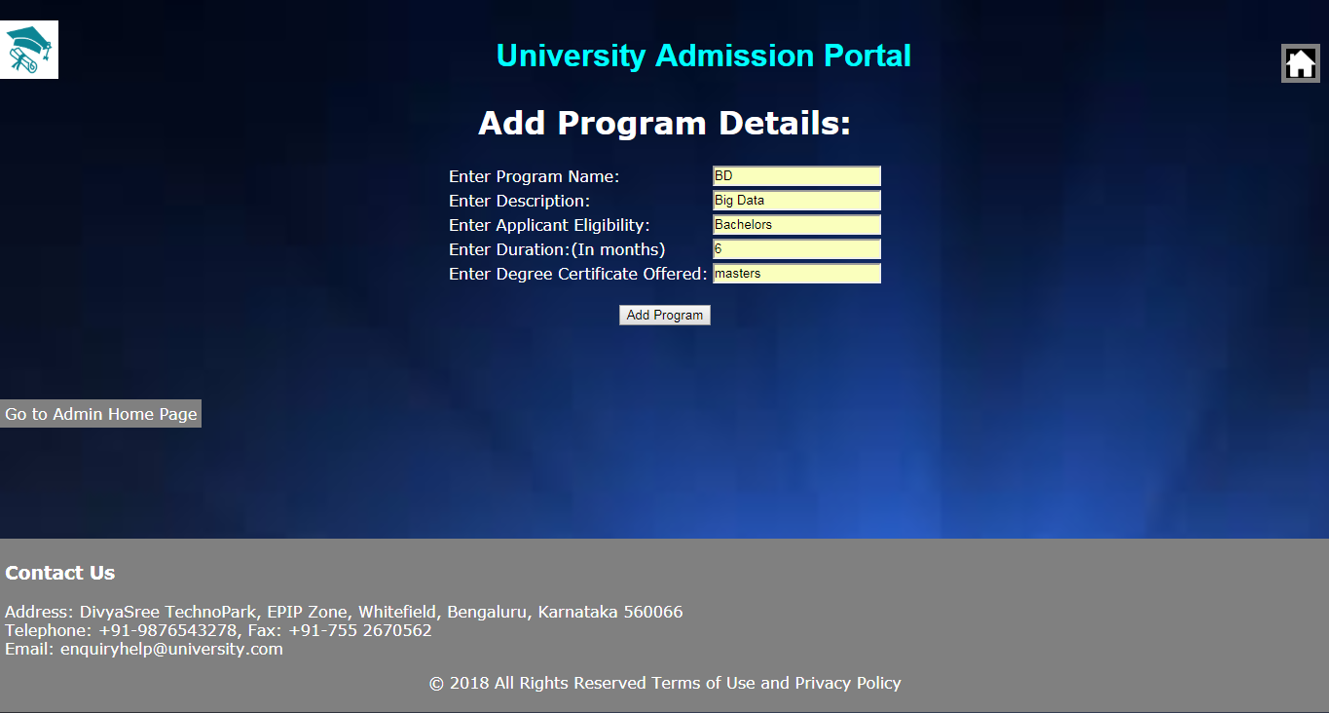

## List Of Design Classes

|  |  |  |  |  |
| --- | --- | --- | --- | --- |
| Sr. No. | **LLD Name** | **Class Name** | **Method Name** | **Method Description** |
| 1 | Add Program Offered Module | ProgramOfferedBean | Appropriate getters and setters methods | Getters retrieve the property values and setters set the property values |
| 2 | Add Program Offered Module | UniversityController | public String getAddProgramsOfferedPage(Model model) | Sets the model attribute.  Calls the Service layer method to insert the program details into the database |
| 3 | Add Program Offered Module | AdminServiceImpl | public ProgramOfferedBean addProgramOffered(ProgramOfferedBean programOfferedBean) throws UniversityException | Calls the DAO layer method to insert the program offered details in the database |
| 4 | Add Program Offered Module | AdminDaoImpl | public ProgramOfferedBean addProgramOffered(ProgramOfferedBean programOffered) throws UniversityException | Inserts the program information into the database and returns the result to AdminServiceImpl |

# Re-Usable Routines/Components

Re-Usable Routines/Components

* CSS files
* UniversityException class
* Log4j properties files

# Messages

|  |  |  |
| --- | --- | --- |
| **#.** | **Type** | **Message Text** |
| M1 | Error | Please enter a valid Program Name (only alphabets, length 1-5). |
| M2 | Error | Program Name is mandatory. |
| M3 | Error | Description is mandatory. |
| M4 | Error | Please enter a valid Description (only alphabets, length 2-20). |
| M5 | Error | Applicant eligibility is mandatory. |
| M6 | Error | Please enter a valid applicant eligibility (only alphabets, length 2-40) |
| M7 | Error | Duration should be 1-24 months |
| M8 | Error | Duration is mandatory |
| M9 | Error | Degree certificate offered is mandatory. |
| M10 | Error | Please enter a valid degree certificate offered (only alphabets, length 2-10) |
| M11 | Error | program Name Already exists!! |
| M12 | Success | Program <programName> is addded successfully. |

# Configuration Files

|  |  |  |
| --- | --- | --- |
| File Name | Path | Description |
| jpaContext.xml | \CapgeminiUniversity\src\main\resources\jpaContext.xml | To configure database connection. |
| web.xml | \CapgeminiUniversity\src\main\webapp\WEB-INF \web.xml | To configure the beans properties. |
| servlet-config.xml | \CapgeminiUniversity\src\main\webapp\WEB-INF\config\servlet-config.xml | To configure the request mapping and view resolver. |
| Log4j.properties | \CapgeminiUniversity\src\main\resources\log4j.properties | To implement logger |

# Crud Matrix Table

|  |  |  |  |  |  |
| --- | --- | --- | --- | --- | --- |
| **#** | **Table Name** | **Create** | **Read** | **Update** | **Delete** |
| 1. | Programs\_Offered | Y | Y | Y | Y |

# Data Mapping Matrix

|  |  |  |  |  |  |  |  |
| --- | --- | --- | --- | --- | --- | --- | --- |
| **Sr. No.** | **Screen Label** | **Field Source** | **Field Type** | **Data Type** | **Max Length** | **Data Flow** | **Mandatory** |
| 1 | Program Name | NA | Label | NA | NA | UI | NA |
| 2 | programName | ProgramOfferedBean.  programName | TextBox | Varchar2(5) | 10 | UI🡪D | Yes |
| 3 | Description | NA | Label | NA | NA | UI | NA |
| 4 | description | ProgramOfferedBean.  description | TextBox | Varchar2(20) | 10 | UI🡪D | Yes |
| 5 | Applicant Eligibility | NA | Label | NA | NA | D🡪UI | NA |
| 6 | applicantEligibility | ProgramOfferedBean.  applicantEligibility | TextBox | Varchar2(40) | 10 | UI🡪D | Yes |
| 7 | Duration | NA | Label | NA | NA | UI | NA |
| 8 | duration | ProgramOfferedBean.  duration | TextBox | Number | 10 | UI🡪D | Yes |
| 9 | Degree Certificate | NA | Label | NA | NA | UI | NA |
| 10 | degreeCertificate | ProgramOfferedBean.  degreeCertificate | TextBox | Varchar2(10) | 10 | UI🡪D | Yes |
| 11 | Add program | NA | Button | NA | NA | UI | NA |

**Legend**

UI (User Interface Only)

UI 🡪 D (User Interface to Database)

# Action Flow Matrix

|  |  |  |  |
| --- | --- | --- | --- |
| **Sr. No.** | **Action** | **Description** | **Process** |
| 1 | On click of Add Program button under Program tab in Admin Homepage | Redirected to the addProgramsOffered page | The admin clicks on the Add Program button in the admin homepage and gets redirected to the addProgramsOffered page. |
| 2 | On click of Add Program button in addProgramsOffered page | The program details are inserted into the database. | Data is entered in the fields by the admin which gets inserted into the database when add button is pressed. |

# Stored Procedures

|  |  |  |  |  |
| --- | --- | --- | --- | --- |
| **#** | **Stored Procedure Name**  **(with Description)** | **Input/Out Parameters** | **Type** | **Size** |
| 1. | NA | NA | NA | NA |

# Program Specification / Pseudo Code

## 14.1<ACTION :ADDPROGRAM\_CLICK >

**Pseudo Code:**

1. **Client Side Scripting:**

None

1. **Server Side Scripting:**

**BEGIN**

Call getAddProgramsOfferedPage() in Controller class

Navigate to addProgramsOffered page

Call validateProgramOfferedDetails() in Controller class

Navigate to addProgramsOffered page

**END**

**14. 2 <ACTION: ADDPROGRAM\_CALL>**

**Pseudo Code:**

1. **Client Side Scripting:**

None

1. **Server Side Scripting:**

**BEGIN**

Call validateProgramOfferedDetails(@ModelAttribute("programOfferedBean")@Valid ProgramOfferedBean programOfferedBean,BindingResult result) in UasController class in Dispacher Servlet

**BEGIN**

Call findoffered(String name) in AdminServiceImpl class in Service Layer

**BEGIN**

Calll findoffered(String name) in AdminDaoImpl class in Data Access Layer

**BEGIN**

Find the records from ProgramsOffered table

Return ProgramOfferedBean.

**END**

Return ProgramOfferedBean to Service Layer

**END**

Return ProgramOfferedBean to UasController

**END**

Else navigate to addProgramsOffered page and show error.

IF successful the go to below steps

**BEGIN**

Call addProgramOffered(programOfferedBean) in AdminServiceImpl class in Service Layer

**BEGIN**

Calll addProgramOffered(ProgramOfferedBean programOfferedBean) in AdminDaoImpl class in Data Access Layer

**BEGIN**

Persisting the object for insert records into ProgramsOffered table

Return ProgramOfferedBean.

**END**

Return ProgramOfferedBean to Service Layer

**END**

Return ProgramOfferedBean to UasController

**END**

IF successful navigate to success page

Else navigate to addProgramsOffered page and show error.

**END**

REVISION HISTORY OF THE WORK PRODUCT

|  |  |  |  |  |  |
| --- | --- | --- | --- | --- | --- |
| # | Date | Version # | Section Changed | Details of changes made | Approved By |
| 1 | 18/9/2018 | 1.0 | LLD prepared | N/A |  |
| 2 | 19/9/2018 | 1.1 | Pseudo code | The pseudo code is modified as per the specified flow. |  |
| 3 | 19/9/2018 | 1.1 | List of Design Class | Method Description of Uas Controller |  |